Year 11 MATHEMATIC METHODS
INVESTIGATION 3, 2015

NAME: ______________________________ Time Allowed: 50 mins
Total Marks : 45

“SNOWFLAKES”
PART A 3 marks

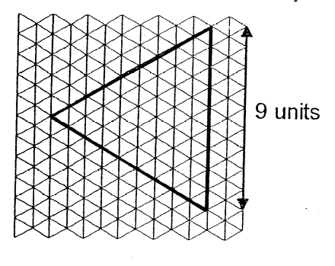
Example: Using the triangle (Δ) as our unit of measure, we could find the perimeter (the distance around the edge) and the area (the space inside a shape) of the equilateral triangle below.

Perimeter = 9 + 9 + 9
= 27 units

Area = 1 + 3 + 5 + 7 + … + 17 triangles
= 81 triangles
(using sum of AP formula)

1. Using the triangle (Δ) as your unit of measure, as above, find the perimeter and area of the equilateral triangle drawn below.

PERIMETER AREA

PART B 42 marks

By continuing this process explained below, “Snowflakes” can be formed.
- divide each side equally into three
- draw equilateral triangles on the middle third of each side.

The first three “snowflakes” are shown below. You will be finding the perimeter and area of each such snowflake in the questions that follow.
Original equilateral
triangle

Snowflake 1

Snowflake 2

Snowflake 3

SNOWFLAKE 1 3 marks

1. Using the triangle (Δ) as your unit of measure, as in Part A above, find the perimeter and area of the first snowflake drawn below.

Remember that perimeter is the total distance around the outside of the shape only.
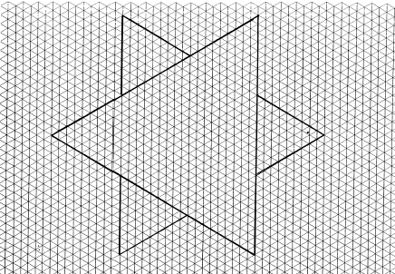
PERIMETER

AREA

SNOWFLAKE 2 5 marks

2. Using the triangle (Δ) as your unit of measure, as above, find the perimeter and area of this second snowflake.
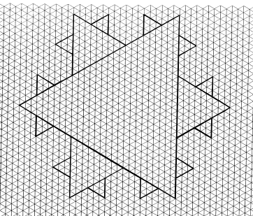
PERIMETER

AREA

SNOWFLAKE 3 6 marks

3. a) On the diagram below, complete the third snowflake.

b) Using the triangle (Δ) as your unit of measure, as above, find the perimeter and area of the third snowflake drawn below.
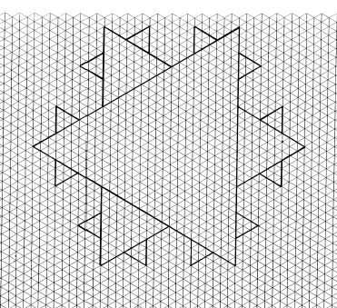
PERIMETER

AREA

4. a) Using your results from the original equilateral triangle and snowflakes 1,2 and
3 and continuing the snowflake pattern, complete the
table below. (Round to 1 dp if necessary)

Snowflake Number | 0 | 1 | 2 | 3 | 4 | 5 | 10
Perimeter (Units)

b) (i) What would the perimeter of the 100th snowflake be?

(ii) Write down the perimeter of the n^{th} snowflake (i.e. the general rule)

6 marks

5. a) Using your results from the original equilateral triangle and snowflakes 1,2 and
3 and continuing the snowflake pattern, complete the
table below. (Round to 1 dp if necessary)

HINT: 729 + a Geometric Series gives the total area of each snowflake.

Snowflake Number | Area | Area = 729 + GP Series
0 | 729
1 |  | = 729 + _______
2 |  | = 729 + _______ + _______
3 |  | = 729 + _______ + _______ + _______
4 |  | = 729 + _______ + _______ + _______ + _______
5 |  | = 729 + _______ + _______ + _______ + _______ + _______

Use the series you have found in the above table to find the area of the 10th snowflake.

b) (i) What is the area of the 100th snowflake?

(ii) Write down the general rule for finding the area of the n^{th} snowflake.

c) If you continued to make an increasingly greater number of snowflakes, what would the area of this ‘infinite’ snowflake be?

20 marks

6. Complete this statement.

With increasing numbers of snowflakes, the perimeter ___________________________

but the area ____________________________________________________________.

2 marks

Yibbida Yibbida, Ah, That’s all Folks!!!

